

REFLECT RETREAT FOR LOCAL PREACHERS
Feb 26-28 2027
Seeing the Spiritual

Art as inspiration in our prayer and our preaching ministry

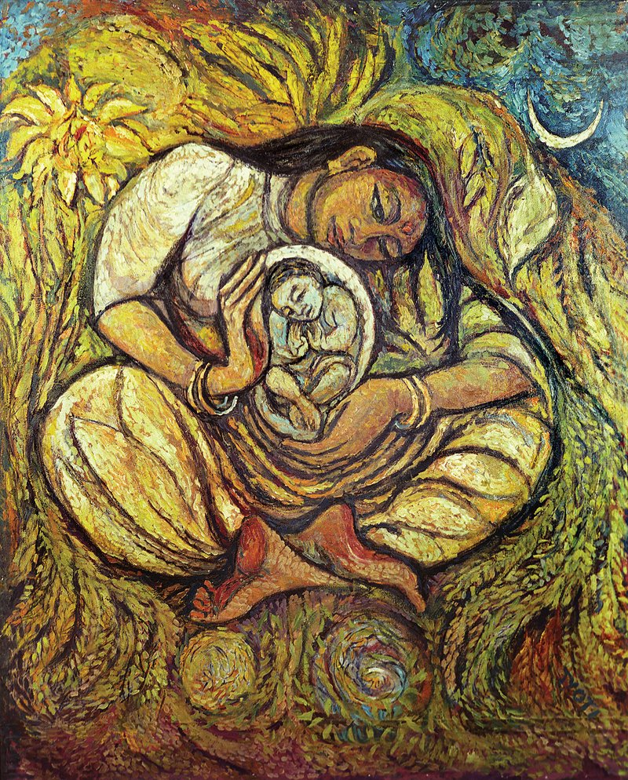

Led by Jo Hibbard

Jo Hibbard is the Director for Heritage and Art for the Methodist Church Connexional Team, and a Local Preacher in the Oxford Circuit. Art and creativity are a passion for her both in her roles in the church and her own spiritual journey.

Cliff College, Calver, Hope Valley, Sheffield S32 3xg

Reflect Retreat for Local Preachers
Friday 26th February to Sunday 28th February 2027
Cost £225

BOOKING FORM
Name
Address
Telephone
Post Code
Email address

Please detail any particular dietary requirements eg vegetarian, diabetic
Please detail any mobility problems eg stairs etc N/A

A non-returnable deposit of £50 per person is required at time of booking.
Please tick below
- by cheque payable to ‘Reflect’, by post to Gill Dascombe, 89 Edinburgh Road, Bolton BL3 1TQ.
Email gilldascombe@hotmail.com

Please do not send cash.

- by BACS transfer to Lloyds Bank ‘Reflect’
Sort Code 30-96-18 Account No 02833113 Ref LP 2025

Please inform Gill when you have sent an electronic payment
Balance of payment of £175 due NOT LATER THAN 31st January 2027
Please reserve me a place on this retreat

Signed ………………………………………………………..Date………………………………………..
Once bookings have been confirmed and paid for, and notification of numbers given to the
Retreat House, no refund can normally be payable.

